Name: Akash Arjun Sawant
Student ID: AF05009971
Batch code: ANP-D1396

Day 6 Lab

Assignment 1. Write a simple HTML with JavaScript program that determines if a given number is positive, negative, or zero. Add a function named checkNumber that takes an integer as an argument and prints a message indicating whether the number is positive, negative, or zero. Add a button to check the input number and show the result on the HTML page in an alert message.
Use an external stylesheet or bootstrap for styling.

Code:

check-number.html

<!DOCTYPE html>
<html>
<head>
<title>Check Number</title>
<link rel="stylesheet" href="style1.css" />
</head>

<body>
<div class="container">
<h2>Check Number <br />(Positive / Negative / Zero)</h2>

<label>Enter a Number:</label>
<input type="number" id="num" placeholder="Enter any integer" />

<button onclick="checkNumber()">Check Number</button>
</div>

<script>
function checkNumber() {
let n = document.getElementById("num").value;

if (n === "") {
alert("Please enter a number!");
return;
}

n = Number(n);

if (n > 0) {
alert(n + " is POSITIVE");
} else if (n < 0) {
alert(n + " is NEGATIVE");
} else {
alert("The number is ZERO");
}
}
</script>
</body>
</html>

style1.css

body {
background-color: #f3f3f3;
font-family: Arial, sans-serif;
}
.container {
width: 350px;
margin: 120px auto;
padding: 25px;
background: white;
border-radius: 10px;
box-shadow: 0 0 10px rgba(0, 0, 0, 0.2);
}
h2 {
text-align: center;
margin-bottom: 20px;
}
input {
width: 94%;
padding: 10px;
margin: 10px 0;
border: 1px solid #aaa;
border-radius: 5px;
}
button {
width: 100%;
background: #007bff;
color: white;
border: none;
padding: 12px;
margin-top: 10px;
border-radius: 5px;
cursor: pointer;
font-size: 16px;
}
button:hover {
background: #005bb5;
}

Output:

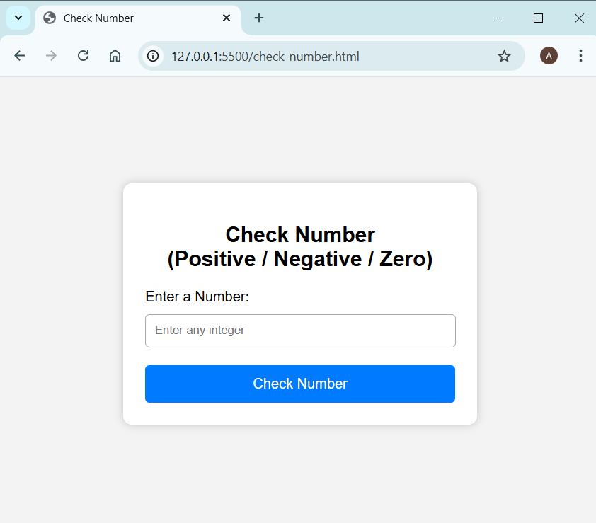
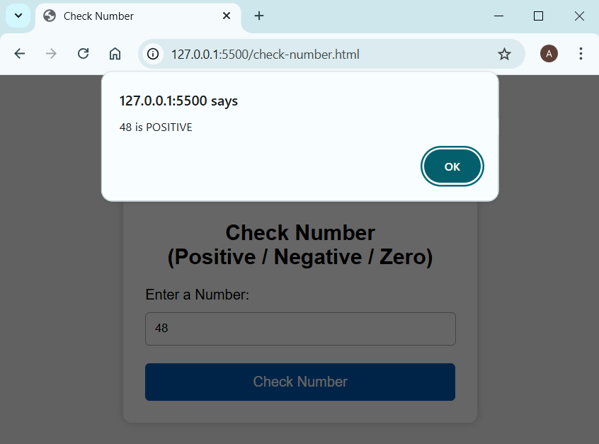

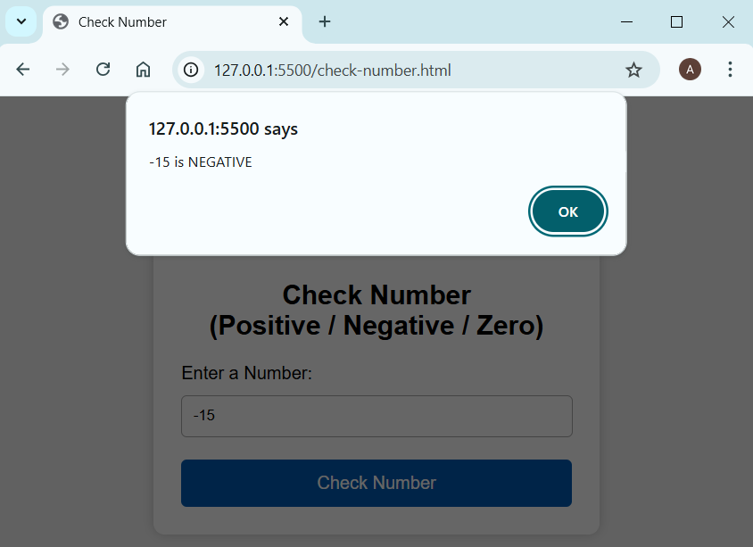
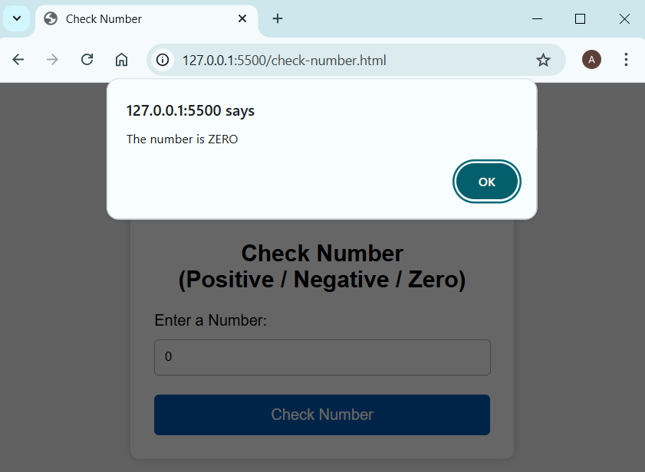

Assignment 2. Write a program that reads the JSON object and dynamically creates an HTML page to display the user's information with the below following details:
● A heading displaying "User Information"
● A section to display user details (Name, Age, Email)
● Takes a JSON object containing user information.
● Dynamically creates HTML elements to display the user's name, age, and email.
● Appends the created elements to the HTML page.
Use an external stylesheet or bootstrap for styling.

Code:

user-information.html

<!DOCTYPE html>
<html>
<head>
<title>User Information</title>
<link rel="stylesheet" href="style2.css" />
</head>

<body>
<div class="container">
<h1>User Information</h1>

<div class="button-row">
<button id="showBtn">Display User Information</button>
<button id="clearBtn" class="clear">Clear</button>
</div>

<div id="user-container" class="box"></div>
</div>

<script>
const user = {
name: "Akash Sawant",
age: 25,
email: "akash@example.com",
};

const container = document.getElementById("user-container");

document.getElementById("showBtn").onclick = function () {
container.innerHTML = "";
container.style.display = "block";

const nameEl = document.createElement("p");
nameEl.innerHTML = `<span class="label">Name:</span> <span class="value">${user.name}</span>`;

const ageEl = document.createElement("p");
ageEl.innerHTML = `<span class="label">Age:</span> <span class="value">${user.age}</span>`;

const emailEl = document.createElement("p");
emailEl.innerHTML = `<span class="label">Email:</span> <span class="value">${user.email}</span>`;

container.appendChild(nameEl);
container.appendChild(ageEl);
container.appendChild(emailEl);
};

document.getElementById("clearBtn").onclick = function () {
container.innerHTML = "";
container.style.display = "none";
};
</script>
</body>
</html>

style2.css

body {
background: #eef3ff;
font-family: Arial, sans-serif;
margin: 0;
display: flex;
justify-content: center;
align-items: center;
}
.container {
text-align: center;
margin-top: 60px;
}
h1 {
color: #0a4cff;
margin-bottom: 25px;
font-size: 32px;
}
/* Buttons row */
.button-row {
display: flex;
justify-content: center;
gap: 15px;
margin-bottom: 20px;
}
button {
padding: 12px 22px;
font-size: 15px;
border: none;
border-radius: 6px;
cursor: pointer;
}
#showBtn {
background: #0a4cff;
color: white;
}
#showBtn:hover {
background: #0839c7;
}
.clear {
background: #ff4141;
color: white;
}
.clear:hover {
background: #cc0000;
}
/* Output Box */
.box {
margin-top: 10px;
background: white;
padding: 20px 30px;
border-radius: 10px;
box-shadow: 0 0 12px rgba(0, 0, 0, 0.2);
width: 350px;
display: none;
text-align: left;
}
.label {
color: #0a4cff;
font-weight: bold;
font-size: 18px;
}
.value {
color: #333;
font-size: 18px;
}

Output:

